Definitions Task
Input

Drag the ‘Word’ oval into the correct box.

Selection
Sprite
Sequence
Iteration

Word | Definition
These are all the ‘steps’ that run in order.
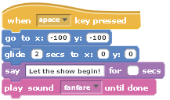
Forever and repeat are examples of this. This is where a sequence of instructions runs until a condition is met.
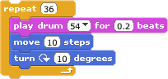
 | An example of this is when someone clicks a mouse button or presses a key.
This is also known as a ‘condition’. IF a condition is met, then certain sequences can run.
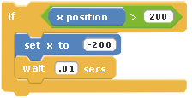
This is a graphic that appears on a stage. Graphics can have different ‘costumes’ to help with animation.


- CHECK YOUR ANSWERS!
- Add your name at the top
- Print

